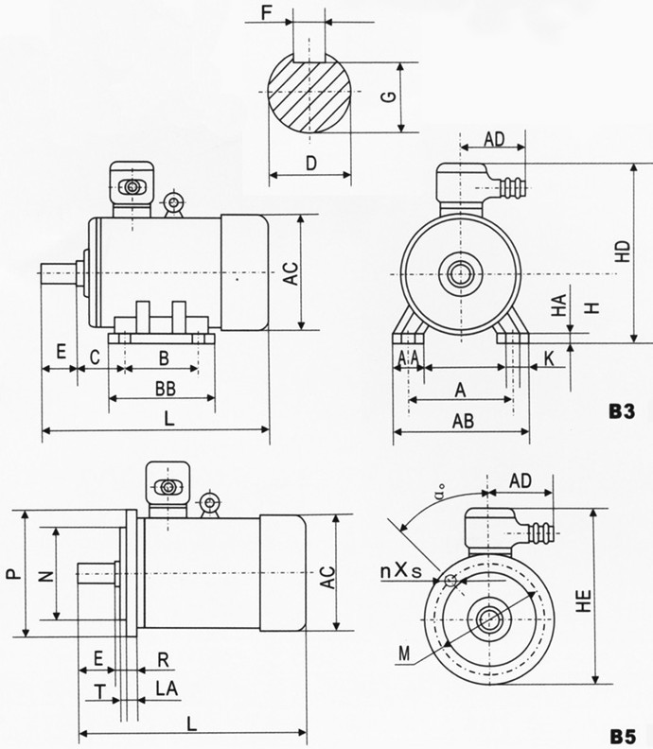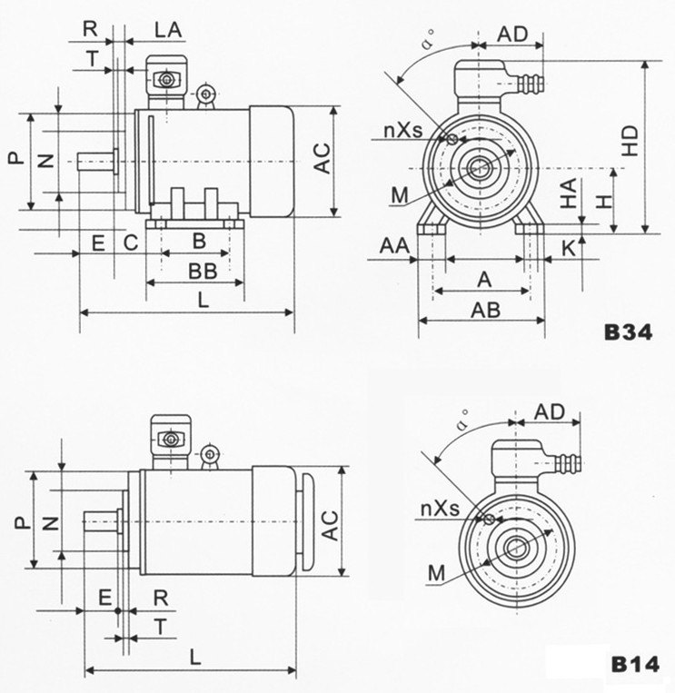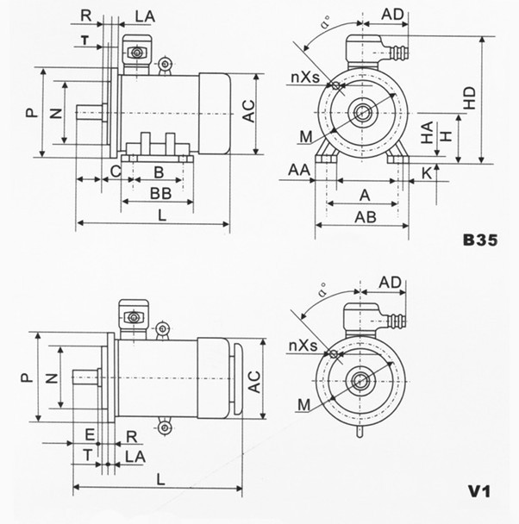
安装及外形尺寸
机座号 | A | B | C | D | E | F | G | H | K | 凸缘尺寸 |  |  |  |  |  |  |  |  |  |  |  |  |  | AA | AB | AC | AD | BB | HA | HD | HE | LA | L
 |  |  |  | 极数 |  |  |  | H | K | B35 B5 V1 |  |  |  |  |  |  | B14 B34
 |  |  |  |  |  |  |  |  |  |  |  |  |  |  |  |  |  |  |  |  |  |  |  |  |  |  |  |  |  |  |  |  | 2P |  | ≥4P
 |  |  |  | 2P≥4P
 |  |  |  |  |  |  |  |  |  | M | N | P | R | a° | nxs | T | M | N | P | R | a° | nxs | T |  |  |  |  |  |  |  |  |  | 其它 | V1 | 其它 | V1
63 | 100 | 80 | 40 | 11 | 23 | 4 | 8.5 | 63 | 7 | 115 | 95 | 140 | 0 | 45 | 4xφ10 | 3.0 | 75 | 60 | 90 | 0 | 45 | 4xM5 | 2.5 | 30 | 130 | 150 | 165 | 110 | 8 | 230 | 230 | 10 | 270 | 310 | 270 | 310
71 | 112 | 90 | 45 | 14 | 30 | 5 | 11 | 71 | 7 | 130 | 110 | 160 | 0 | 45 | 4xφ10 | 3.0 | 85 | 70 | 105 | 0 | 45 | 4xM6 | 2.5 | 32 | 140 | 155 | 165 | 130 | 8 | 240 | 240 | 12 | 300 | 340 | 300 | 340
80 | 125 | 100 | 50 | 19 | 40 | 6 | 15.5 | 80 | 10 | 165 | 130 | 200 | 0 | 45 | 4xφ12 | 3.5 | 100 | 80 | 120 | 0 | 45 | 4xM6 | 3.0 | 34 | 165 | 165 | 180 | 135 | 10 | 320 | 240 | 15 | 330 | 375 | 330 | 375
90S | 140 | 100 | 56 | 24 | 50 | 8 | 20 | 90 | 10 | 165 | 130 | 200 | 0 | 45 | 4xφ12 | 3.5 | 115 | 95 | 140 | 0 | 45 | 4xM8 | 3.0 | 36 | 180 | 180 | 180 | 135 | 14 | 350 | 355 | 15 | 360 | 405 | 360 | 405
90L | 140 | 125 | 56 | 24 | 50 | 8 | 20 | 90 | 10 | 165 | 130 | 200 | 0 | 45 | 4xφ12 | 3.5 | 115 | 95 | 140 | 0 | 45 | 4xM8 | 3.0 | 36 | 180 | 180 | 180 | 160 | 14 | 350 | 355 | 15 | 385 | 430 | 385 | 430
100L | 160 | 140 | 63 | 28 | 60 | 8 | 24 | 100 | 12 | 215 | 180 | 250 | 0 | 45 | 4xφ15 | 4.0 | 130 | 110 | 160 | 0 | 45 | 4xM8 | 3.5 | 40 | 200 | 205 | 180 | 180 | 14 | 400 | 400 | 18 | 440 | 485 | 440 | 485
112M | 190 | 140 | 70 | 28 | 60 | 8 | 24 | 112 | 12 | 215 | 180 | 250 | 0 | 45 | 4xφ15 | 4.0 | 130 | 110 | 160 | 0 | 45 | 4xM8 | 3.5 | 50 | 245 | 230 | 200 | 185 | 16 | 420 | 420 | 18 | 460 | 520 | 460 | 520
132S | 216 | 140 | 89 | 38 | 80 | 10 | 33 | 132 | 12 | 265 | 230 | 300 | 0 | 45 | 4xφ15 | 4.0 |  |  |  |  |  |  |  | 60 | 280 | 270 | 200 | 205 | 18 | 450 | 490 | 20 | 510 | 590 | 510 | 590
132M | 216 | 178 | 89 | 38 | 80 | 10 | 33 | 132 | 12 | 265 | 230 | 300 | 0 | 45 | 4xφ15 | 4.0 |  |  |  |  |  |  |  | 60 | 280 | 270 | 200 | 242 | 18 | 450 | 490 | 20 | 550 | 630 | 550 | 630
160M | 254 | 210 | 108 | 42 | 110 | 12 | 37 | 160 | 15 | 300 | 250 | 350 | 0 | 45 | 4xφ19 | 5.0 |  |  |  |  |  |  |  | 70 | 330 | 325 | 220 | 275 | 20 | 520 | 530 | 20 | 655 | 730 | 655 | 730
160L | 254 | 254 | 108 | 42 | 110 | 12 | 37 | 160 | 15 | 300 | 250 | 350 | 0 | 45 | 4xφ19 | 5.0 |  |  |  |  |  |  |  | 70 | 330 | 325 | 220 | 320 | 20 | 520 | 530 | 20 | 695 | 770 | 695 | 770

